Assignment -3 Bucket and Watson assistant

|  |  |
| --- | --- |
| Assignment Date | 7 October 2022 |
| Student Name | PRANAV DEVI R. |
| Student Roll Number | CITC19 05 036 |
| Maximum Marks | 2 Marks |

Questions:

1. **Create a Bucket in IBM object storage.**

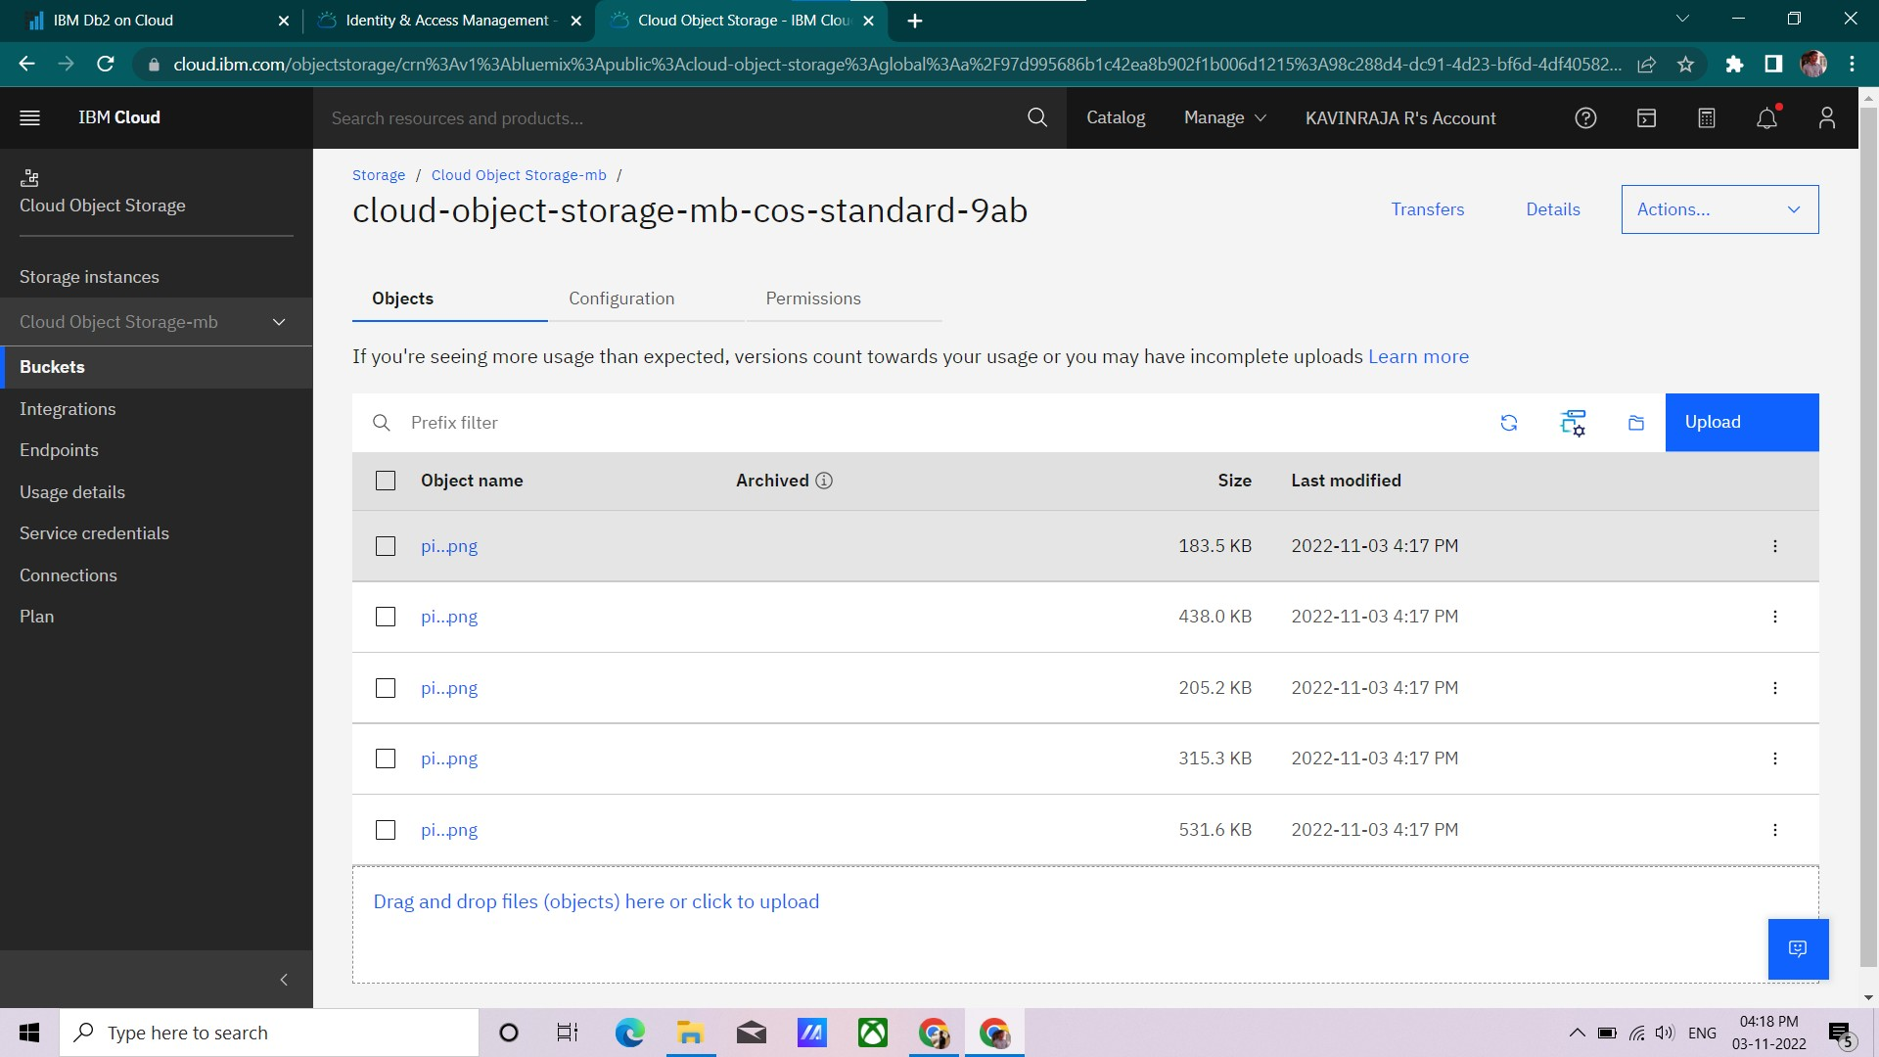

1. **Upload an 5 images to ibm object storage and make it public. write html code to displaying all the 5 images.**

Index.html

<!DOCTYPE *html*>

<html *lang*="en">

<head>

<meta *charset*="UTF-8">

<meta *http-equiv*="X-UA-Compatible" *content*="IE=edge">

<meta *name*="viewport" *content*="width=device-width, initial-scale=1.0">

<title>Smart Fashion shop </title>

<style>

body {

background-color: aqua; display: flex;

align-items: center; justify-content: center;

flex-direction: column;

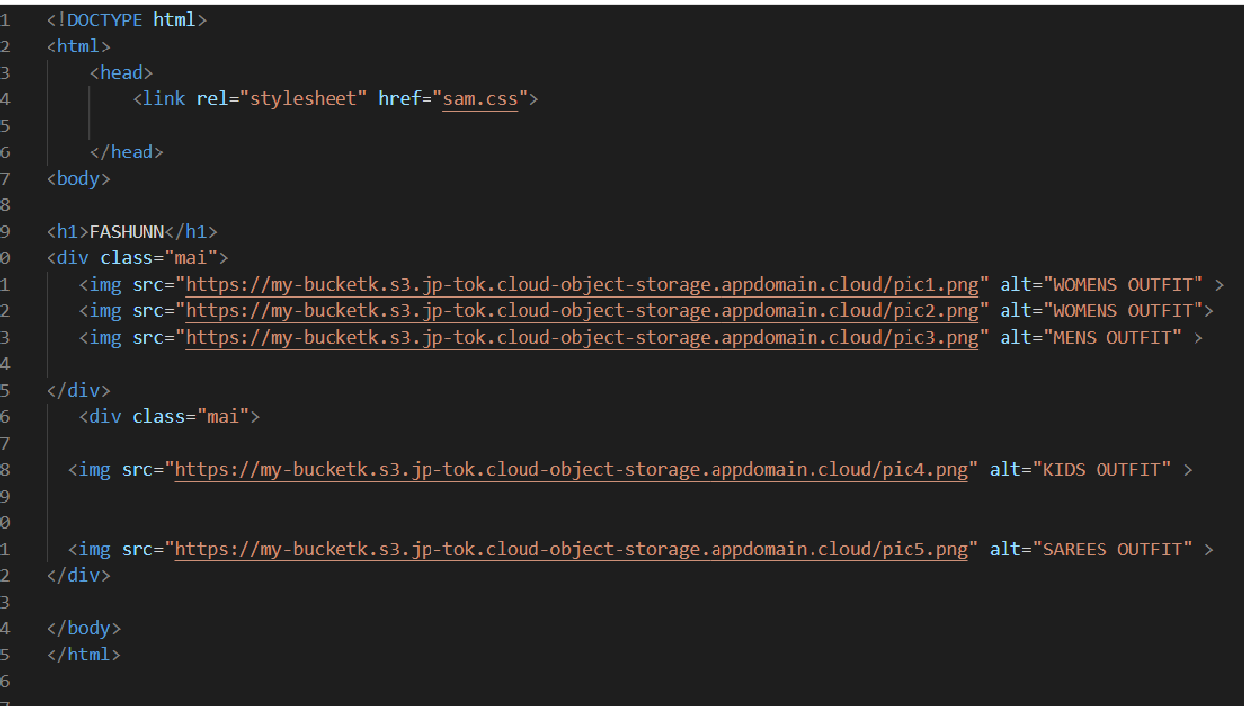

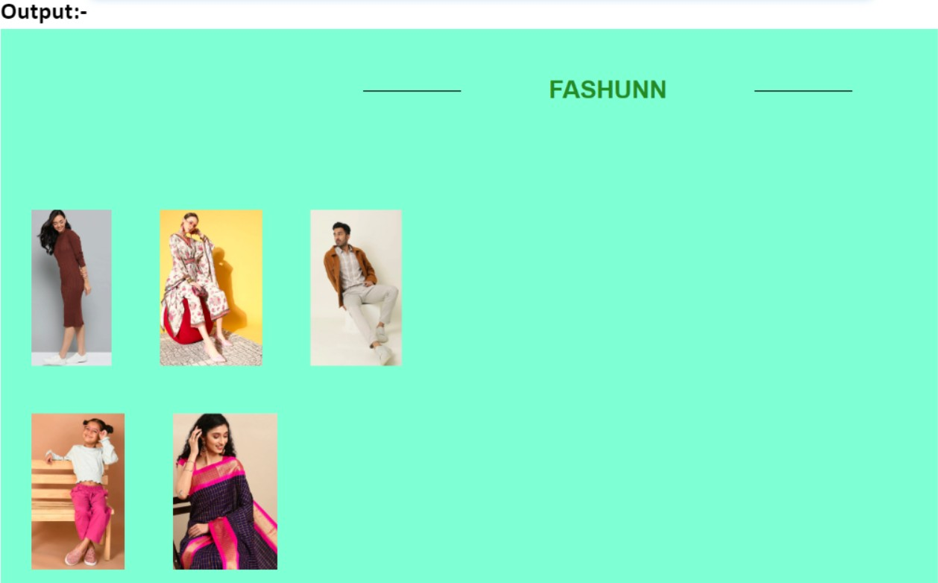

1. **Upload a css page to the object storage and use the same page in your HTML code.**

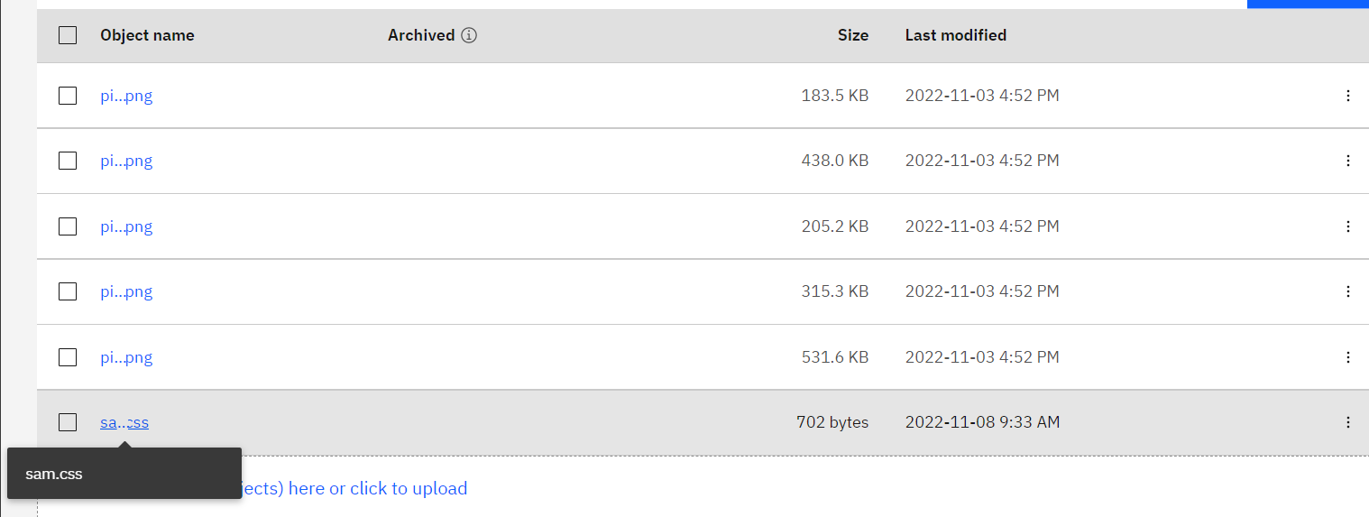

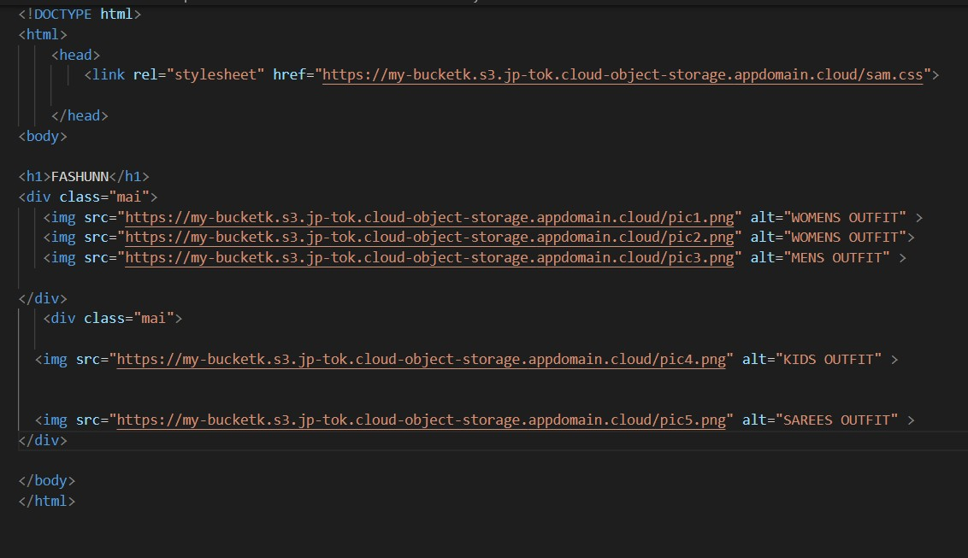

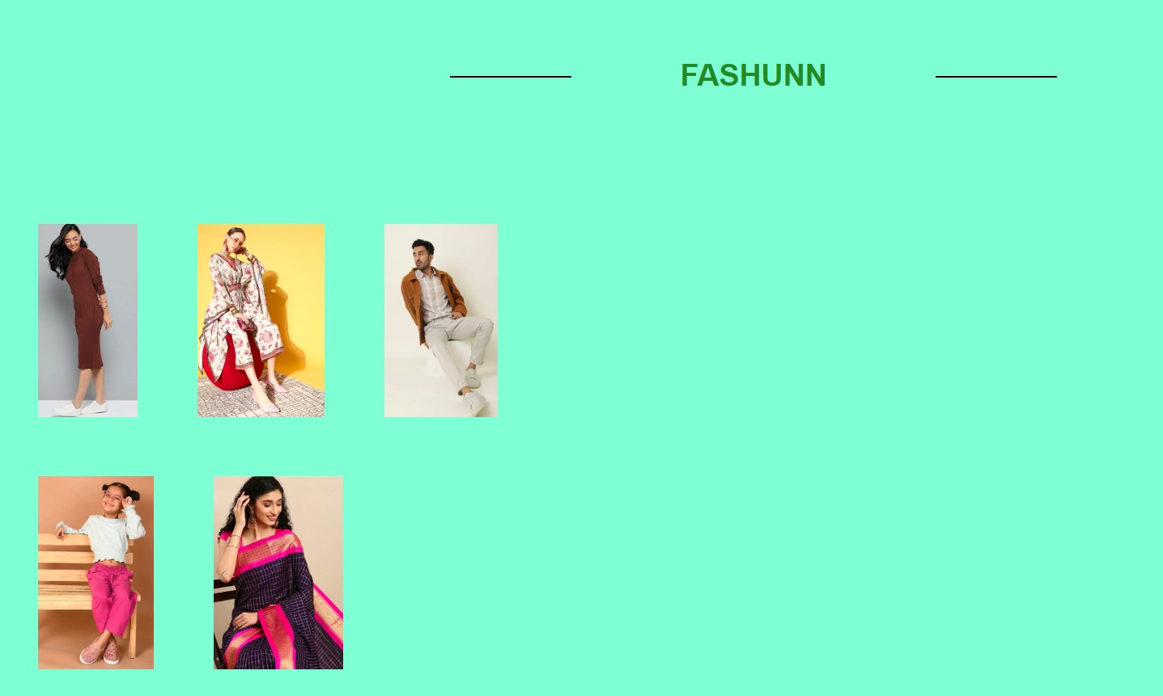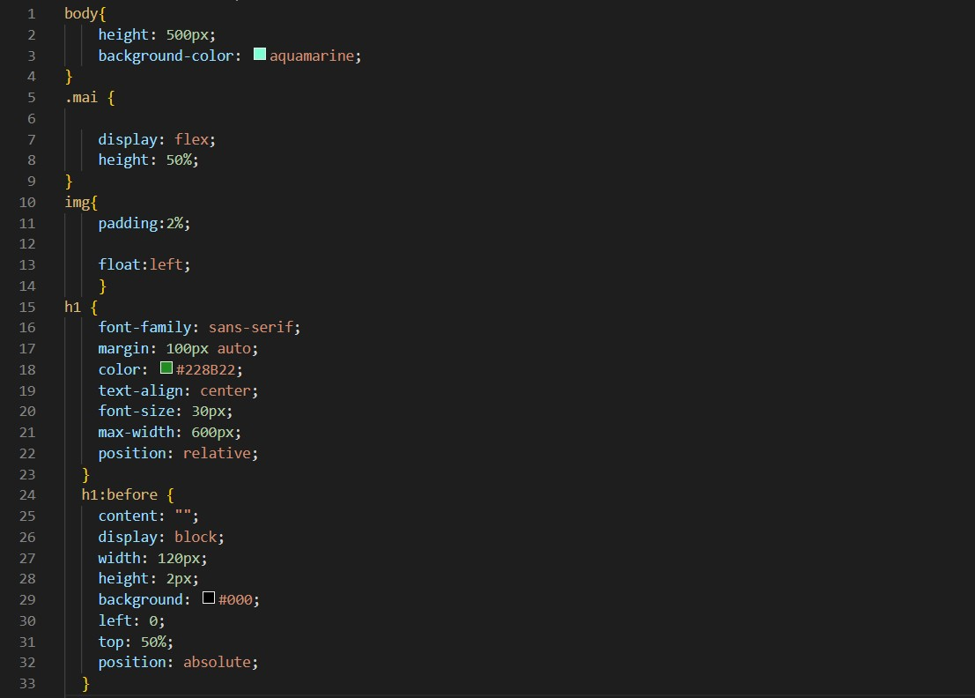Output:-

<img *src*="https://imagebucket-vk.s3.ap.cloud-object-

storage.appdomain.cloud/yves-monrique-LR99Ho2eIec-unsplash.jpg"

*alt*="Dress" *srcset*="">

</div>

</body>

</html>

1. 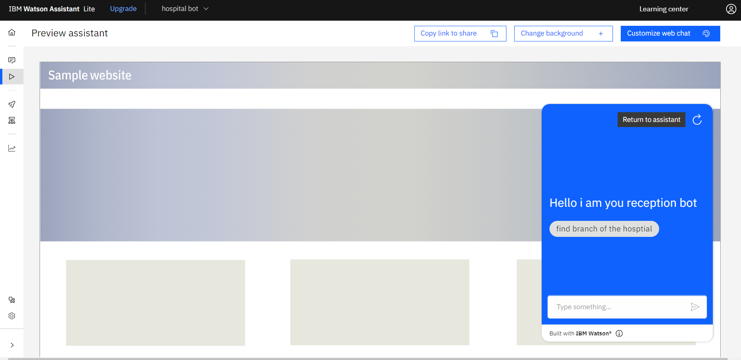**Design a chatbot using IBM Watson assistant for hospital. Ex: User comes with query to know the branches for that hospital in your city. Submit the web URL of that chat bot as a assignment.**

Url :- chatbot link <- click

Image-

5 .Create Watson assistant service with 10 steps and use 3 conditions in it. Load that script in HTML page

